**Homework #5**

**SQL Exercises: Based on the SQL script file for Pine Valley Furniture Company, write the SQL statements for the following queries.**

1. **What are the names of all the customers who have placed orders?**

SELECT CUSTOMER_ID, CUSTOMER_NAME, ORDER_ID

FROM S_CUSTOMER_T NATURAL JOIN S_ORDER_T

ORDER BY ORDER_ID;

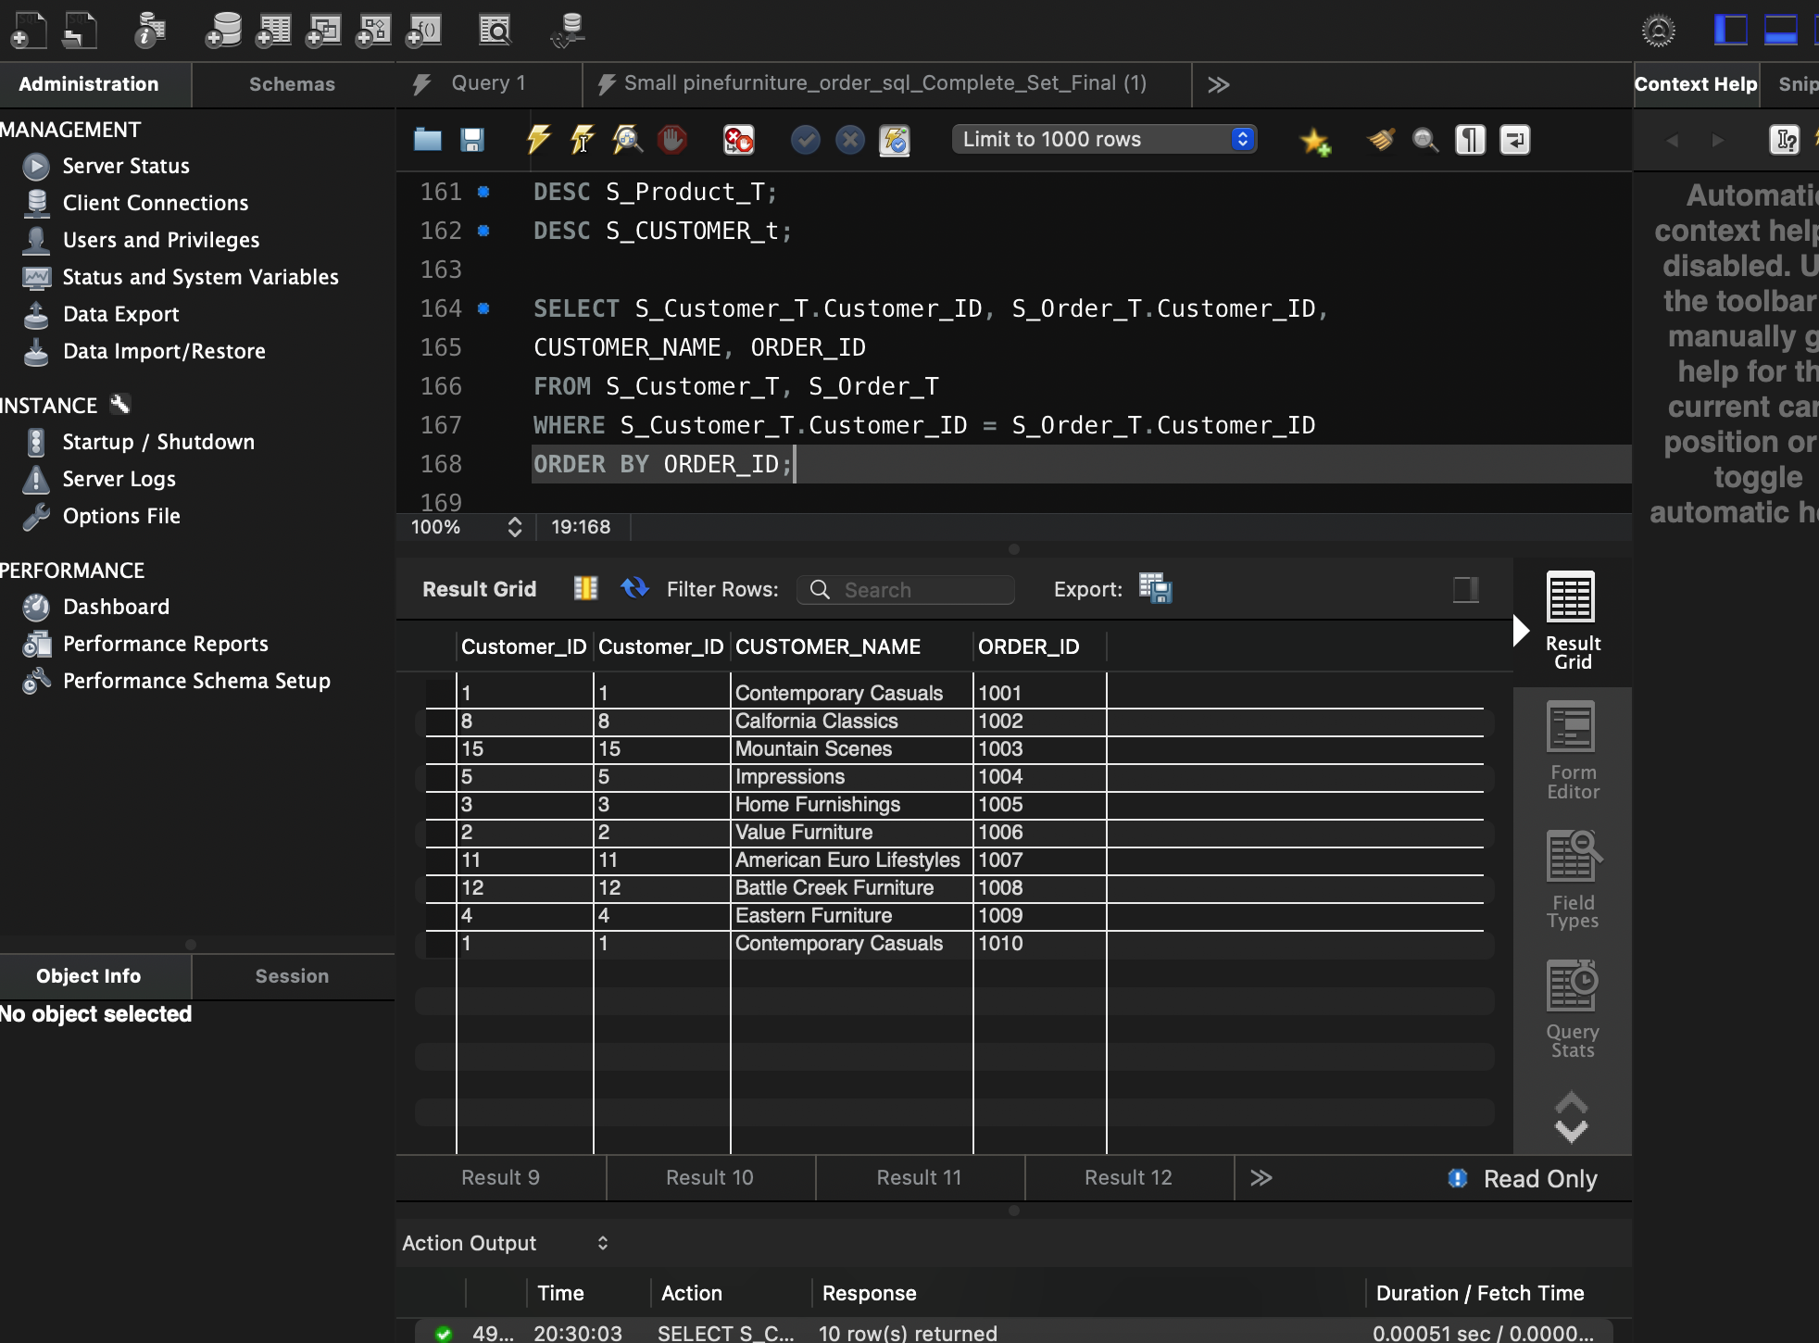

1. **What are the product descriptions ordered by the customer ID, 1?**

SELECT p.Product_Description

FROM S_Order_T o

JOIN S_ORDER_LINE_T ol ON o.Order_ID=ol.Order_ID

JOIN S_Product_t ON ol.Product_ID=p.Product_ID

WHERE o.Customer_ID=1;

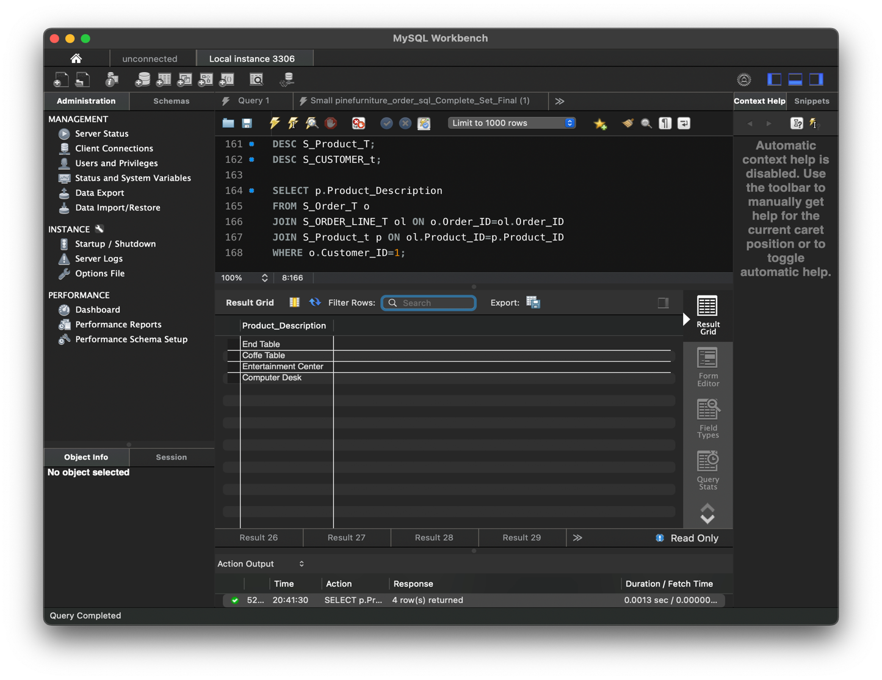

1. **What are the product descriptions ordered by the customer, ‘Impressions’?**

SELECT p.Product_Description

FROM S_Order_T o

JOIN S_Customer_t c ON o.Customer_id=c.Customer_ID

JOIN S_Order_Line_t ol ON o.Order_Id=ol.Order_ID

JOIN S_Product_t p ON ol.Product_ID=p.Product_ID

WHERE c.Customer_Name=’Impressions’;

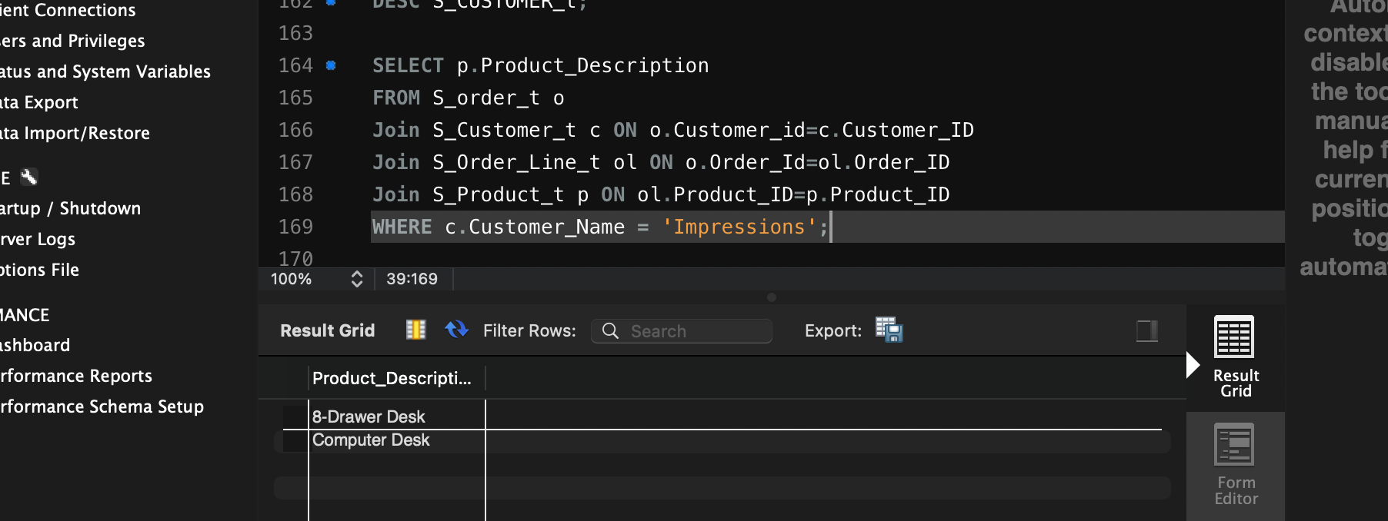

1. **List all customers’ names that have placed an order that contains a product whose standard price is over $500.**

SELECT DISTINCT c.Customer_Name

FROM S_Customer_t c

JOIN S_Order_t o ON c.Customer_id=o.Customer_id

JOIN S_Order_Line_t ol ON o.Order_Id=ol.Order_id

JOIN S_Product_t p ON ol.Product_ID=p.Product_ID

WHERE p.Standard_Price > ‘500’;

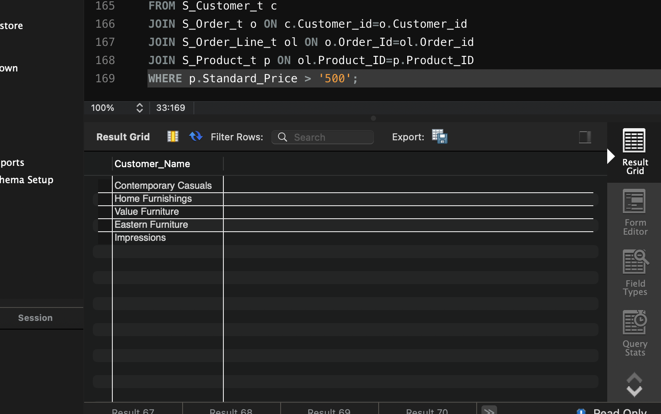

1. **List all customers. Print the order ID(s) along the customer information if they have submitted the order(s).**

SELECT c.Customer_ID, c.Customer_Name, o.Order_ID

FROM S_Customer_T c

LEFT JOIN S_Order_T o ON c.Customer_ID=o.Customer_ID;

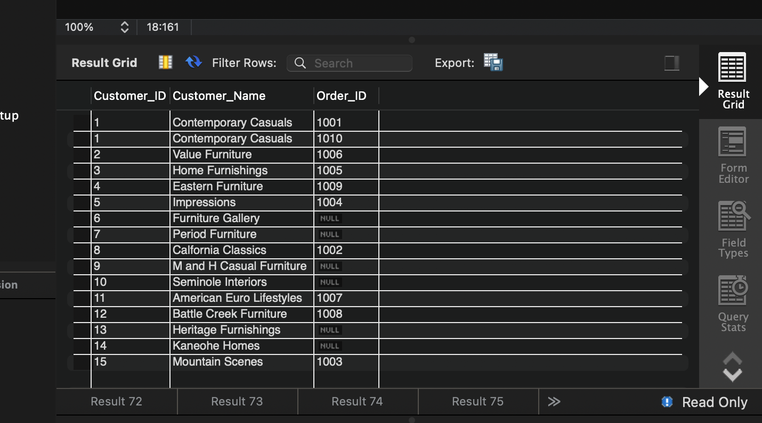

1. **Display the subtotal amount of each order line in each order.**

SELECT ol.Order_ID, p.Product_Description, p.Standard_Price*ol.Ordered_Quantity AS Subtotal

FROM S_Order_Line_t ol

JOIN S_Product_t p ON ol.Product_ID;

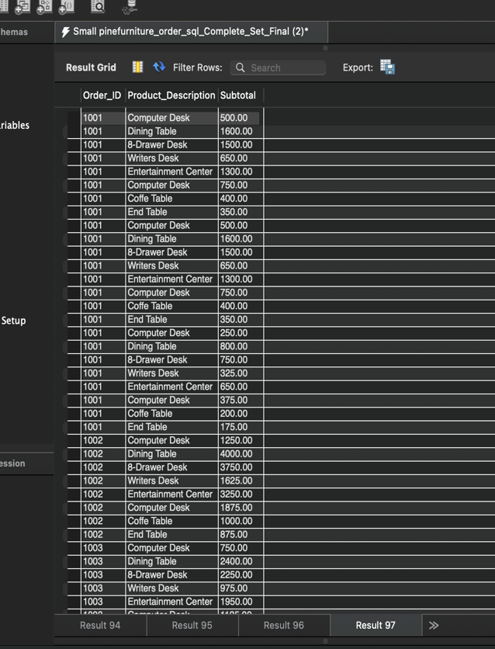 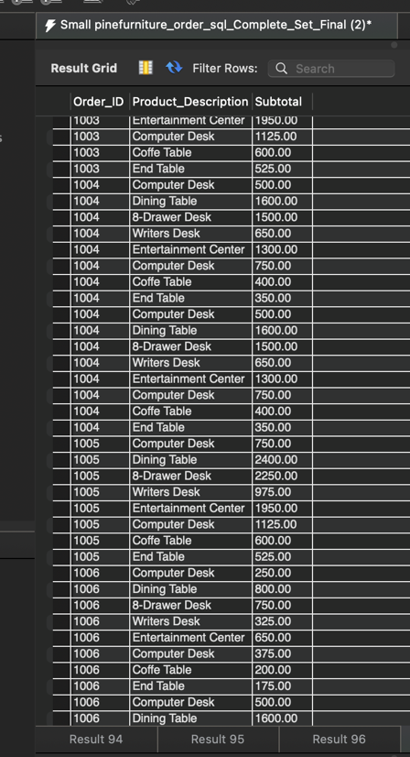

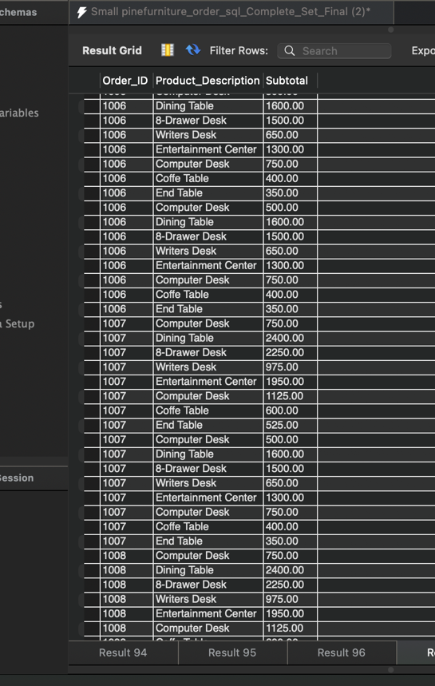 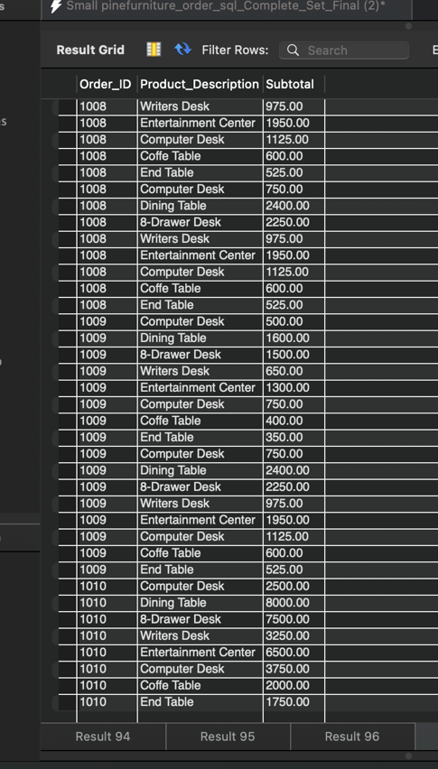

1. **Display the total amount of each other**.

SELECT o.Order_ID, SUM(p.Standard_Price*ol.Ordered_Quantity) AS Total

FROM S_Order_t o

JOIN S_Order_Line_t ol ON o.Order_Id=ol.Order_Id

JOIN S_Product_t p ON ol.Product_ID=p.Product_Id

GROUP BY o.Order_ID;

